2



**Business Requirement Document**

**OLSS – CR Enhancement Management Module**

**PT. Berlian Sistem Informasi**



## Proposed Functionality

1. **Functionality of Monitoring OPL Unit and Replacement Unit Tab OPL Unit.**

This module will show all DSF Unit with status active car, stock car, replacement car. => opening status?

1. **Additional field in screen Monitoring OPL Unit and Replacement Unit Tab OPL Unit.**

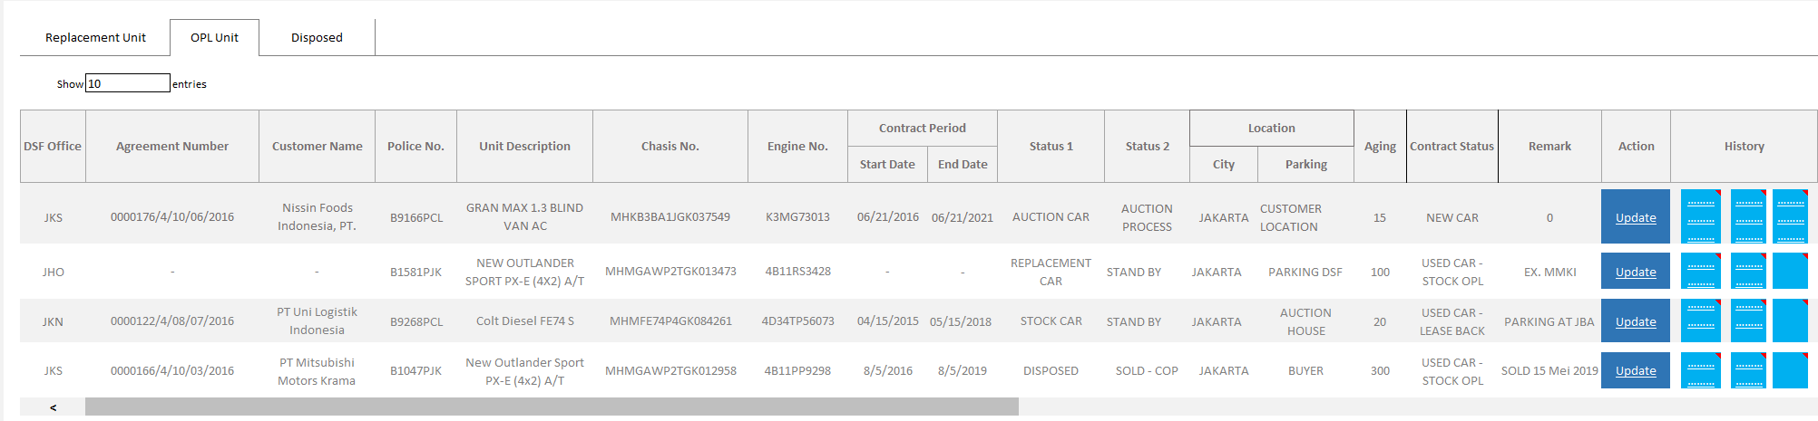

*New Screen Monitoring OPL Unit & Replacement Unit Tab OPL Unit*

* Contract Period – Start Date : Showing Start Date Contract from Start Period Agreement Date.
* Contract Period – End Date : Showing End Date Contract from End Period Agreement Date.
* Status 1 : Showing car status 1 contain active, replacement car, stock car and disposed.
* Status 2 : Showing car status 2 contain in use/ running contract, service, body repair, end contract, STNK/ KEUR Renewal

Process, Stand By, Waiting for Delivery, Used As GTS, Used As Replacement Car, Sold – Auction, Sold – COP, Total

Loss, Transfer to Finance Lease, Transfer to New Agreement.

* Aging : Showing how long the unit is in the status.
* Location – City : Showing city location of the car.
* Location – Parking : Showing car location which contain Customer Location, Workshop, Auction

House, Parking at DSF.

* Remark : Showing remarks from user.
* Update Button : To change above status.
* View Button : Showing Contract History, Daily Car Record, and Maintenance History.

1. **Action Button “Update”.**

This button used for updating the information in Screen Monitoring OPL Unit and Replacement Unit Tab OPL Unit. The button will only give to Pak Pathul, Pak Didy, Pak Fahmi, Pak Anton & Bu Nada. When button clicked, it will show Screen **Update Daily Record Car**.

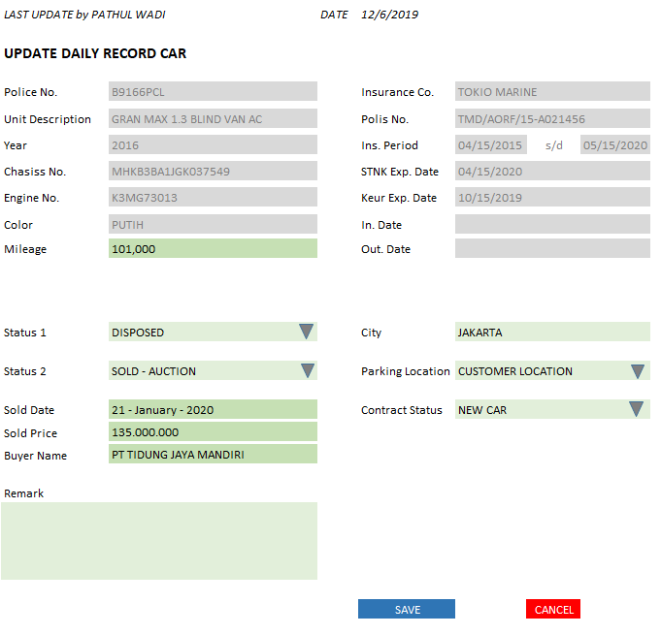

*Screen Update Daily Record Car*

* Last Update By : The last user that update Daily Record Car and the date.
* Police Number : Showing police number of the unit (view only).
* Unit Description : Showing model name of the unit (view only).
* Year : Showing model year of the unit (view only).
* Chassis No. : Showing chassis number of the unit (view only).
* Engine No. : Showing engine number of the unit (view only).
* Color : Showing color of the unit (view only).
* Mileage : Showing the last update mileage and can be edited to input the actual mileage.

Field cannot be empty.

* Insurance Co. : Showing Insurance Company (view only).
* Polis No. : Showing Polis Number (view only).
* Insurance Period : Showing Period Insurance from and Period Insurance To (view only).
* STNK Exp. Date : Showing STNK Expired date (view only).
* KEUR Exp. Date : Showing KEUR Expired date (view only).
* In Date : Showing date when parking location is Customer Location.
* Out Date : Showing date when parking locations are Workshop, Auction House and

Parking at DSF.

* Status 1 : Showing dropdown list of car status:
  + - * Active = unit that used for active agreement.
      * Replacement Car = unit that used for replacing active car.
      * Stock Car = unit that mostly used for active agreement or replace active car.
      * Disposed = unit that already sold, claimed to insurance for total loss or transfer to new agreement.

Will load the last update status. If status 1 changed, then Status 2 and Parking

Location will be blank. Mandatory field.

* Status 2 : Showing dropdown list based on Status 1:

|  |  |
| --- | --- |
| Status 1 | Status 2 |
| Active | In Use/ Running Contract  Service  Body Repair  End Contract  STNK/ KEUR Renewal Process |
| Replacement Car | Stand By  Service  Body Repair  Waiting for Delivery  STNK/ KEUR Renewal Process  Used As GTS  Used As Replacement Car |
| Stock Car | Stand By  Service  Body Repair  Waiting For Delivery  STNK/ KEUR Renewal Process  Used As GTS  Used As Replacement Car  Action Process |
| Disposed | Sold – Auction  Sold – COP  Total Loss  Transfer to Finance Lease  Transfer to New Agreement |

* City : Showing car city location. Will load the last update status. Mandatory field.
* Parking Location : Showing car location dropdown list which contain:
  + - * Customer Location
      * Workshop
      * Auction House
      * Parking at DSF
* Sold Date : Date of the unit is sold/ disposed (will be shown only when Status 1 is Disposed,

data is from asset selling and can be edited).

* Sold Price : Actual Price of the unit sold (will be shown only when Status 1 is Disposed, data

is from asset selling and can be edited).

* Buyer’s Name : Name of buyer that buy the unit (will be shown only when Status 1 is Disposed,

data is from asset selling and can be edited).

* Contract Status : Showing contract status dropdown list contain New Car, Used Car – Stock OPL,

Used Car – Lease Back.

* Remark : Additional information.
* Save button : If clicked, then it will insert new record to database and will be recognized as

last update record.

* Close button : If clicked, then it will show pop up warning “Do you want to close the pop

up without save?”. If yes, pop up will close without saving the record. If no, pop up still remain.

1. **History Button.**

There are 3 history buttons:

1. **Contract history**

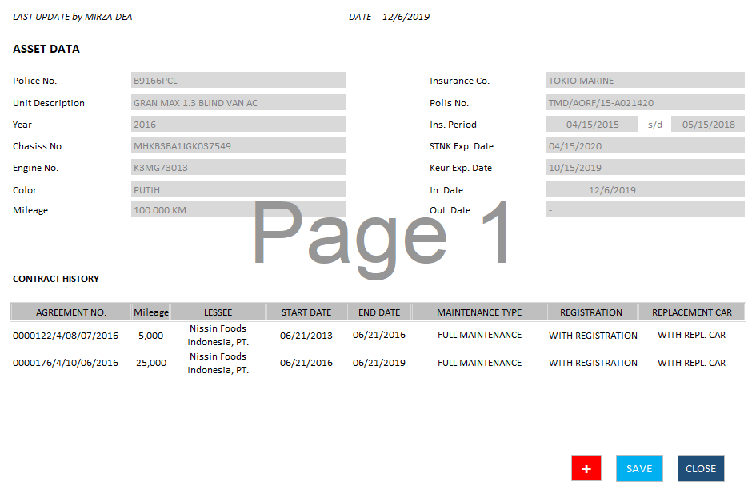

*View Contract History*

* Last Update By : The last user that update Daily Record Car and the date.
* Police Number : Showing police number of the unit (view only).
* Unit Description : Showing model name of the unit (view only).
* Year : Showing model year of the unit (view only).
* Chassis No. : Showing chassis number of the unit (view only).
* Engine No. : Showing engine number of the unit (view only).
* Color : Showing color of the unit (view only).
* Mileage : Showing the last update mileage (view only).
* Insurance Co. : Showing Insurance Company (view only).
* Polis No. : Showing Polis Number (view only).
* Insurance Period : Showing Period Insurance from and Period Insurance To (view only).
* STNK Exp. Date : Showing STNK Expired date (view only).
* KEUR Exp. Date : Showing KEUR Expired date (view only).
* In Date : Showing date when parking location is Customer Location.
* Out Date : Showing date when parking locations are Workshop, Auction House and

Parking at DSF.

* Agreement No. : Showing history agreement that use the selected unit.
* Mileage : Showing history of last mileage per agreement.
* Lessee : Showing customer name.
* Start Date : Showing start period agreement.
* End Date : Showing end period agreement.
* Maintenance Type : Showing type of maintenance.
* Registration : Showing with registration or no registration.
* Replacement Car : Showing with replacement car or without replacement car.
* Add button :
* Save button : To save record into the database.
* Close button : To close the pop up and back to the Monitoring OPL Unit and Replacement

Unit.

1. **Daily Record Car History**

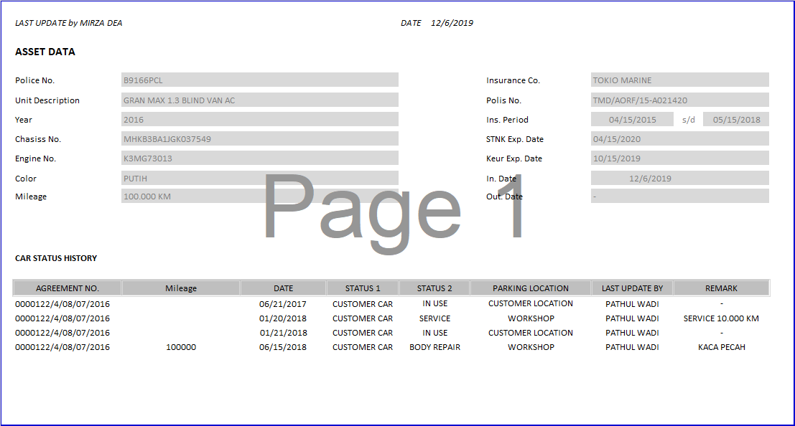

*View Contract History*

* Last Update By : The last user that update Daily Record Car and the date.
* Police Number : Showing police number of the unit (view only).
* Unit Description : Showing model name of the unit (view only).
* Year : Showing model year of the unit (view only).
* Chassis No. : Showing chassis number of the unit (view only).
* Engine No. : Showing engine number of the unit (view only).
* Color : Showing color of the unit (view only).
* Mileage : Showing the last update mileage (view only).
* Insurance Co. : Showing Insurance Company (view only).
* Polis No. : Showing Polis Number (view only).
* Insurance Period : Showing Period Insurance from and Period Insurance To (view only).
* STNK Exp. Date : Showing STNK Expired date (view only).
* KEUR Exp. Date : Showing KEUR Expired date (view only).
* In Date : Showing date when parking location is Customer Location.
* Out Date : Showing date when parking locations are Workshop, Auction House and

Parking at DSF.

* Agreement No. : Showing agreement number active that use the unit.
* Mileage : Mileage’s history which updated in Update Daily Record Car screen.
* Date : Daily Record Car update’s date.
* Status 1 : Showing car status 1 contain active, replacement car, stock car and disposed.
* Status 2 : Showing car status 2 contain in use/ running contract, service, body repair, end

contract, STNK/ KEUR Renewal Process, Stand By, Waiting for Delivery, Used As

GTS, Used As Replacement Car, Sold – Auction, Sold – COP, Total Loss, Transfer

to Finance Lease, Transfer to New Agreement.

* Parking Location : Showing car location which contain Customer Location, Workshop, Auction

House, Parking at DSF.

* Last Update By : Daily Record Car last update user.
* Remark : Daily Record Car remarks history.

1. **Maintenance History**

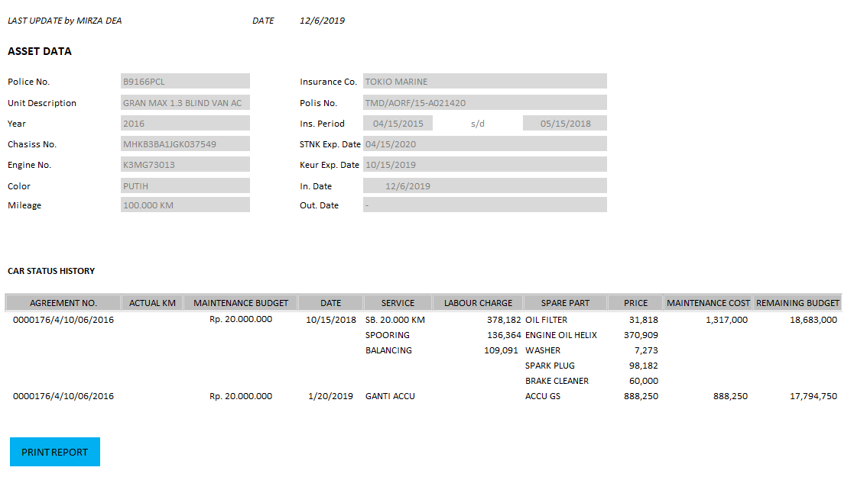

*View Maintenance History*

* Last Update By : The last user that update Daily Record Car and the date.
* Police Number : Showing police number of the unit (view only).
* Unit Description : Showing model name of the unit (view only).
* Year : Showing model year of the unit (view only).
* Chassis No. : Showing chassis number of the unit (view only).
* Engine No. : Showing engine number of the unit (view only).
* Color : Showing color of the unit (view only).
* Mileage : Showing the last update mileage (view only).
* Insurance Co. : Showing Insurance Company (view only).
* Polis No. : Showing Polis Number (view only).
* Insurance Period : Showing Period Insurance from and Period Insurance To (view only).
* STNK Exp. Date : Showing STNK Expired date (view only).
* KEUR Exp. Date : Showing KEUR Expired date (view only).
* In Date : Showing date when parking location is Customer Location.
* Out Date : Showing date when parking locations are Workshop, Auction House and

Parking at DSF.

* Agreement No. : Showing agreement number active that use the unit.
* Actual KM : Showing actual km (mileage) when maintenance conducted.
* Maintenance Budget: Showing budget maintenance fee.
* Date : Maintenance date
* Service : Item maintenance detail in history List of Maintenance Schedule which “Is

Service” is ticked.

* Labour Charge : Price for Service Cost.
* Spare Part : Item maintenance detail in history List of Maintenance Schedule which “Is

Service” is not ticked.

* Price : Price for Spare Part cost.
* Maintenance Cost : Total or labour charge and Spare Part Price per maintenance.
* Remaining Budget : The last remaining budget minus present maintenance cost.

1. **Print Report in Maintenance History View.**
2. **Link unit that sold from Asset Selling Module to OPL Unit.**
3. **Search Criteria in Monitoring OPL Unit and Replacement Unit Tab OPL Unit.**

There will be additional criteria in search criteria dropdown list name “Contract Status”. This criteria parameter contain New Car, Used Car – Stock OPL, Used Car – Lease Back.

1. **Report in Monitoring OPL Unit and Replacement Unit Tab OPL Unit.**

When user click “Print Report” button in Monitoring OPL Unit and Replacement Unit Tab OPL Unit, it will show popup for type report:

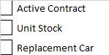

These checkboxes showing contract status of the unit. After user select the status, it will show the report. The report will show:

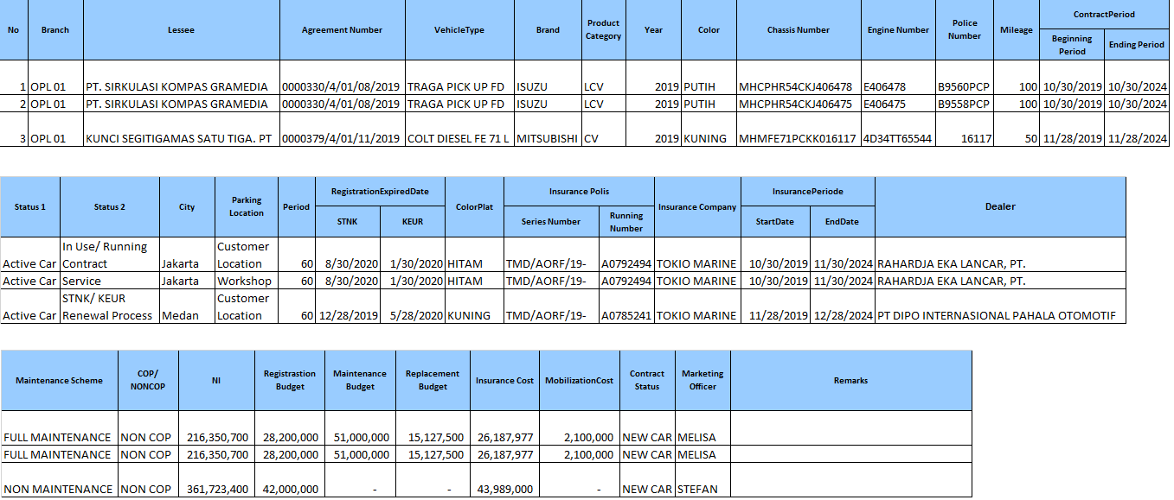

*Template for Print Report in Monitoring Unit And Replacement Module Tab OPL Unit*

* No. : Running Number.
* Branch : OPL with branch number from Agreement (example: OPL 01 for JHO, OPL 02 for JKC)
* Lessee : Lessee of the agreement.
* Agreement Number : Agreement Number.
* Vehicle Type : Model Name.
* Brand : Brand of the Unit.
* Product Category :
* Year : Model Year.
* Color : Unit Color.
* Chassis Number : Unit Chassis Number.
* Engine Number : Unit Engine Number.
* Police Number : Unit Police Number
* Mileage : Last Mileage Update.
* Beginning Period (Contract) : Agreement Start Date Period
* Ending Period (Contract) : Agreement End Date Period
* Status 1 : Status of the unit 1.
* Status 2 : Status of the unit 2.
* City : City of the unit location.
* Parking Location : Unit Location.
* Period : Lease Period Plan.
* STNK (Reg Expired Date) : STNK Expired Date.
* KEUR (Reg Expired Date) : KEUR Expired Date.
* Color Plat : Color of Police Plat.
* Series Number (Ins. Polis) : Series Number of Insurance Polis.
* Running Number (Ins. Polis) : Running Number of Insurance Polis.
* Insurance Company : Company of the Insurance.
* Ins Period (Start Date) : Start Period of Insurance.
* Ins Period (End Date) : End Period of Insurance.
* Dealer : Vendor of Unit Purchase.
* Maintenance Scheme : Type of maintenance.
* COP/ NON COP : Purchase Requirement After Lease, if yes then COP, if no then NON COP.
* NI : Net Investment of the unit.
* Registration Budget : Budget for renewal STNK and/ or KEUR.
* Maintenance Budget : Budget for maintenance unit.
* Replacement Budget : Budget for replacement unit.
* Insurance Cost : Cost for insurance.
* Mobilization Cost : Cost for mobilization from vendor to customer.
* Contract Status : Showing contract status dropdown list contain New Car, Used Car – Stock OPL,

Used Car – Lease Back.

* Marketing Officer : Marketing officer that
* Remarks :

1. **New Tab “Disposed” in Monitoring OPL Unit and Replacement Unit.**

There will be a new tab named “Disposed” that contains data of unit that status 1 is disposed. When user change status 1 to **Disposed**, the row will be move from tab **OPL Unit** to **Disposed**.

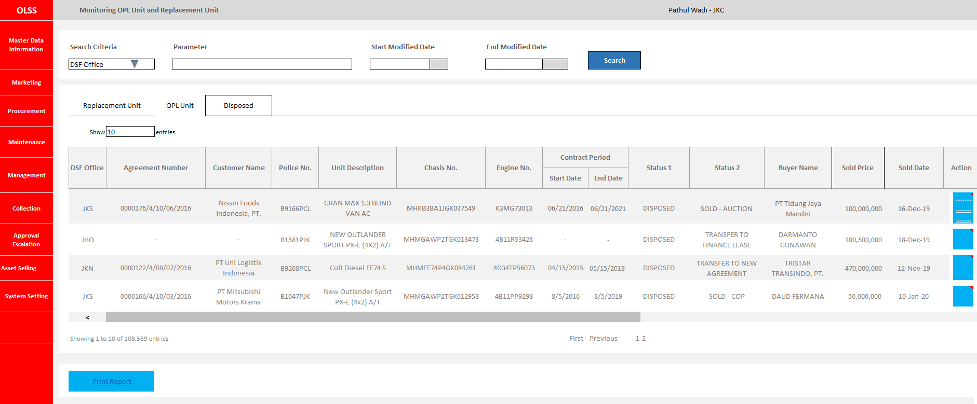

*New Screen for Monitoring OPL Unit and Replacement Unit Module Tab* ***Disposed****.*

1. **Print Report in Monitoring Unit and Replacement Unit Module Tab Disposed.**

View & print report?

1. **View of Monitoring Document Complement Module.**

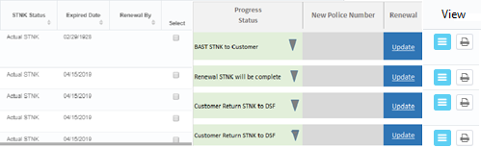

*Additional Field in Monitoring Document Complement View*

* Column Progress Status and New Police Number wider than before so user can see the text.
* When change information in Progress Status and New Police Number column, after user click save button, the information still showing.
* New button Update to input new entry about renewal STNK & KEUR and see history renewal STNK & KEUR. This button has limited access.
* New button View to view (only) history of renewal STNK & KEUR. This button can be accessed by everyone.
* New button printout to print the history of renewal STNK & KEUR.
* Budget nya beda antara stnk & keur. Apa mau digabung atau pisah?

1. **Update Button for Renewal STNK & KEUR.**

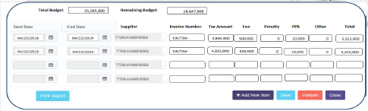

*Additional Field in Monitoring Document Complement View*

* Total Budget : Budget registration from Calculation step 2 – Registration Value Amount
* Remaining Budget : Budget registration minus total amount of renewal STNK & KEUR
* Start Date : Start period of STNK/ KEUR
* End Date : End period of STNK/ KEUR
* Supplier : Supplier that manage the renewal STNK & KEUR
* Invoice Number : Invoice number of renewal STNK & KEUR
* Tax Amount : Tax amount of renewal STNK & KEUR
* Fee : Fee expense of renewal STNK & KEUR
* Penalty : Cost of renewal after the expired date.
* PPh : Withholding Tax of renewal STNK & KEUR
* Other : Other Expense of renewal STNK & KEUR
* Total : Tax amount + Fee + Penalty – PPh + Other
* Print Report : Button to print the history of renewal STNK & KEUR
* Add New Item :
* Save :
* Validate :
* Close :

1. **Print Report “STNK & KEUR Renewal History”**

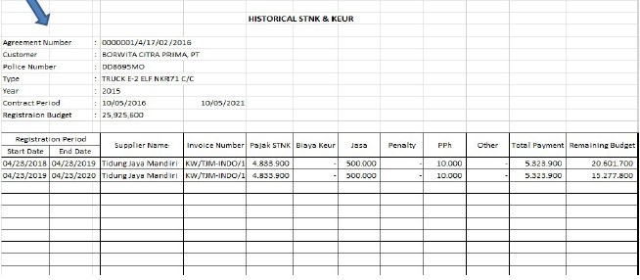

*Report Historical STNK & KEUR Renewal*

* Start Date : Start period of STNK/ KEUR
* End Date : End period of STNK/ KEUR
* Supplier Name : Supplier that manage the renewal STNK & KEUR
* Invoice Number : Invoice number of renewal STNK & KEUR
* Pajak STNK : Tax amount of renewal STNK & KEUR
* Biaya KEUR :
* Jasa : Fee expense of renewal STNK & KEUR
* Penalty : Cost of renewal after the expired date.
* PPh : Withholding Tax of renewal STNK & KEUR
* Other : Other Expense of renewal STNK & KEUR
* Total Payment : Tax amount + Fee + Penalty – PPh + Other
* Remaining Budget : Budget Registration left minus Total Payment